Logging using Microsoft.Extensions.Logging

Using Microsoft ILogger interface to add logging features. This can be used for production process but for scaling up to a bigger user base and high volume use a third-party system instead of simple implementation of ILogger.

Guide Topics:
- Installing the packages
- Code setup
- Usage
- Additional notes

Installing the packages
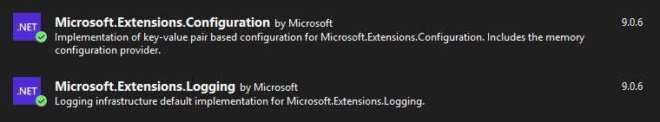
Note: Microsoft.Extensions.Configuration is optional but useful to control the systems variables.

Code Setup
- Add FileLogger inheriting from ILogger.
Minimally override this function to print to console or save log to file.
public void Log<TState>
- Create the appsettings.json into the project. This is loaded through the initiating class GlobalLogger.cs
example: appsettings.json
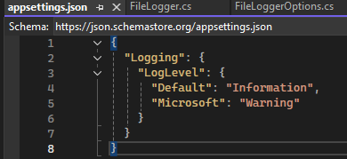
Important note: To make this work the appsettings.json must be copy over to the build folder.
Steps to tell build to copy the file appsettings.json to build folder.
- Right click on appsettings.json > Properties
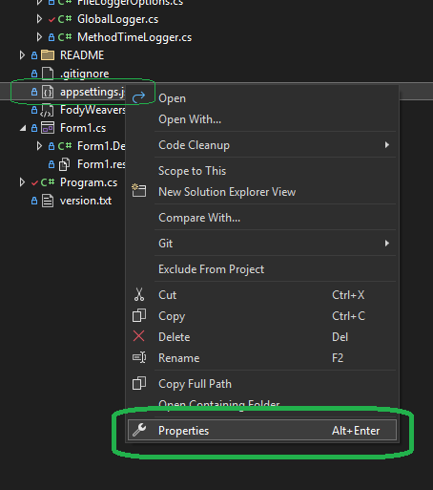
- Set the Build Action=None, Copy to Output Directory=<pick any Copy option>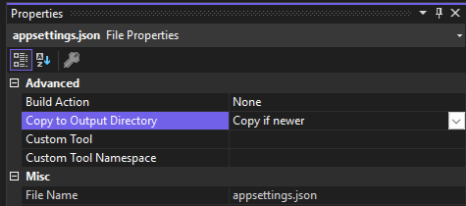
- This will turn into this code in the project xml file CSharpAppPlayground.csproj
<ItemGroup>
<None Update="appsettings.json">
<CopyToOutputDirectory>PreserveNewest</CopyToOutputDirectory>
</None>
</ItemGroup>
- Initialize the logger in Program.cs before the app begins.

Usage
Simple example:

// ILogger logger = new FileLogger("CSharpAppPlayground", new FileLoggerOptions { FilePath = "log.txt", LogLevel = LogLevel.Information });
// logger.LogInformation("Application started.");

Once initialized in the project the ILogger has logLevels
Possible LogLevels from ILogger
Enum name | Enum value | ILogger extension method
Trace | 0 | LogTrace
Debug | 1 | LogDebug
Information | 2 | LogInformation
Warning | 3 | LogWarning
Error | 4 | LogError
Critical | 5 | LogCritical
None | 6

Based on the LogLevel passed the function gets called or not, If the LogLevel is above Warning then LogInformation will not be recorded
GlobalLogger.Instance.LogInformation("Run Clicked");

Additional Notes
The Log will be saved in the bin folder once it’s built and ran.
example:
~\CSharpAppPlayground\bin\Debug\net8.0-windows

Sources:
https://www.roundthecode.com/dotnet-tutorials/how-aspnet-core-logging-works-ilogger-loglevel

Logging using log4net (TO DOCUMENT)
/*
TODO DOCUMENT STEPS TO SETUP LOG4NET:
1. add log4net package via NuGet
2. configure log4net with log4net.config file
3. use Logger static class to log messages
4. add PerfLogHelper.PushPerfProperties() before logging performance messages for CPU and MEM info
5. add [assembly: log4net.Config.XmlConfigurator(ConfigFile = "log4net.config")] to Program.cs
6. add this to .csproj
<None Update="log4net.config">
<CopyToOutputDirectory>PreserveNewest</CopyToOutputDirectory>
</None>
*/

